**GROUP DATA BY MONTH AND YEAR** 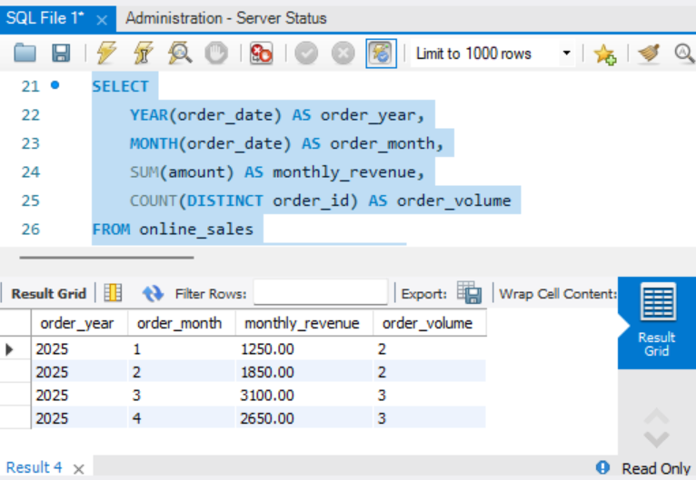

**LIMIT FOR SPECIFIC TIME PERIODS** 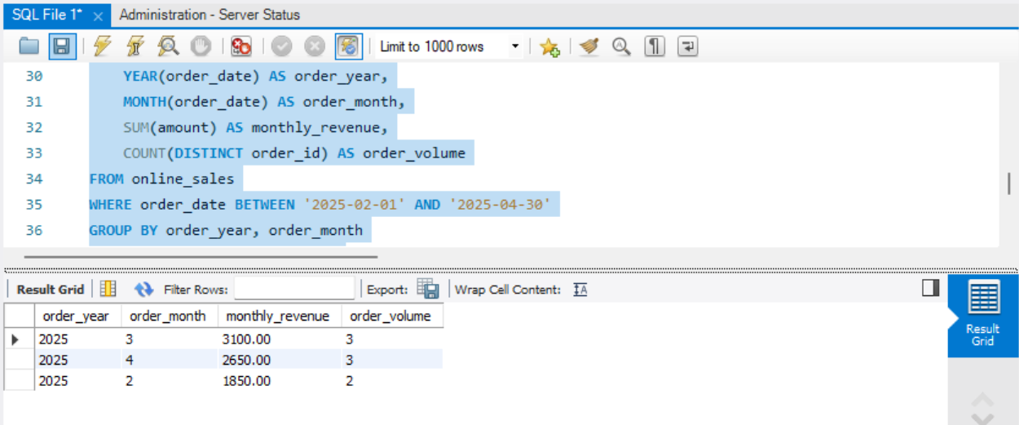

**TOP 3 MONTHLY SALES**

